|  |  |
| --- | --- |
| **Assignment Case** |  |
| COMP6799001  Database Technology |
| **Computer Science** | **O233-COMP6799001-VA09-01** |
| ***Valid on*** *Odd Semester Year 2022/2023* | **Revision 00** |

1. Seluruh mahasiswa tidak diperkenankan untuk:

*All students are not allowed to:*

* + - Berdiskusi dan/atau bekerja sama dengan mahasiswa lainnya,

*Discuss and/or work together with other student participants,*

* + - Melihat sebagian atau seluruh jawaban mahasiswa lain,

*Seeing a part or the whole answer from another student,*

* + - Membuka dan menyalin dari **BUKU** atau **CATATAN**, **VIDEO** dari pengajar (recording kelas, VBL, Youtube, dsb) dan **REFERENSI** lainnya,

*Open and copy from any resources such as notes, videos (class recording, VBL, Youtube, etc) and other references,*

* + - Membuka dan menyalin jawaban dari internet (google, stackoverflow, dsb),

*Open and copy answer from the internet (google, stackoverflow, etc),*

* + - Mengerjakan soal yang tidak sesuai dengan tema yang ada di soal,

*Working with another theme which is not in accordance with the existing theme in the matter of the case,*

* + - Melakukan tindakan kecurangan lainnya,

*Committing other dishonest actions,*

* + - Secara sengaja maupun tidak sengaja melakukan segala tindakan kelalaian yang menyebabkan hasil karyanya berhasil dicontek oleh orang lain / kelompok lain.

*Accidentally or intentionally conduct any failure action that cause the results of the project was copied by someone else / other groups.*

1. Jika mahasiswa terbukti melakukan tindakan seperti yang dijelaskan butir 1 di atas, maka **nilai mahasiswa** yang melakukan kecurangan (menyontek maupun dicontek) akan di – **NOL** – kan.

*If the student is proved to the actions described in point 1 above, the score of the student which committed dishonest acts (cheating or being cheated) will be “Zero”.*

1. Perhatikan jadwal pengumpulan jawaban, segala jenis pengumpulan jawaban di luar jadwal tidak dilayani.

*Pay attention to the submission schedule, all kinds of submission outside the schedule will not be accepted.*

1. Bila Anda tidak membaca peraturan ini, maka Anda dianggap telah membaca dan menyetujuinya

*If you have missed to read these regulations, so you are considered to have read and agreed on it.*

1. Persentase penilaiaan untuk matakuliah ini adalah sebagai berikut:

*Marking percentage for this subject is described as follows:*

|  |  |  |
| --- | --- | --- |
| **Tugas Mandiri**  *Assignment* | **Proyek**  *Project* | **UAP**  *Final Exam* |
| 40% | - | 60% |

1. Software yang digunakan pada matakuliah ini adalah sebagai berikut:

*Software will be used in this subject are described as follows:*

|  |
| --- |
| **Software**  *Software* |
| XAMPP 8.0.7 |

1. Ekstensi file yang harus disertakan dalam pengumpulan tugas mandiri, proyek, dan uap untuk matakuliah ini adalah sebagai berikut:

*File extensions should be included in assignment, project, and final exam collection for this subject are described as follows:*

|  |  |  |
| --- | --- | --- |
| **Tugas Mandiri**  *Assignment* | **Proyek**  *Project* | **UAP**  *Final Exam* |
| SQL | - | SQL |

**Tabel Relasional**

*Relational Table*

**OkieVA**

**OkieVA** is an online store that sell handmade cookies. Because of its increasing popularity, it is getting harder to handle the transaction data. You are asked to help **OkieVA** managing their database transaction.

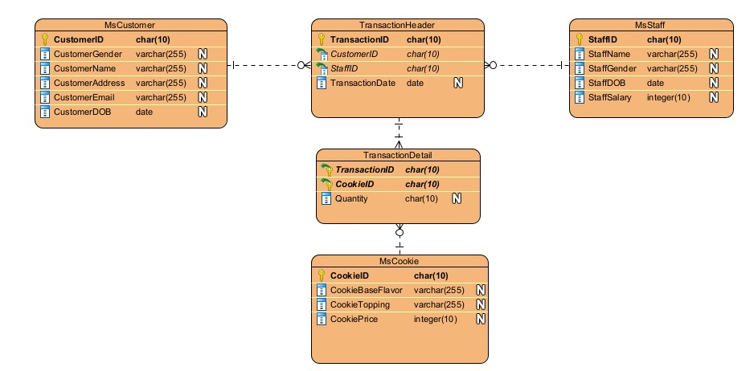

## Soal

*Case*

**Note**: Import ‘okieva’ database before answering the questions below.

1. Create a **table** named ‘**MsCoupon**’ with the following description:

**(CREATE TABLE)**

|  |  |  |  |
| --- | --- | --- | --- |
| **Field Name** | **Data Type** | **Length** | **Description** |
| CouponID | CHAR | 10 | **Primary Key**. |
| CustomerID | CHAR | 10 | References from **MsCustomer.** If the referenced data is changed then the changes will be cascaded. |
| DiscountAmount | INT | 10 | Cannot be empty. |
| ExpiredDate | DATE | - | Cannot be empty. |

1. **Insert** this data into **MsCoupon** table:

**(INSERT)**

|  |  |  |  |
| --- | --- | --- | --- |
| **MsCoupon** | | | |
| CouponID | CustomerID | DiscountAmount | ExpiredDate |
| CP001 | CO001 | 20 | 5th April 2023 |

1. Display **CustomerName, CustomerEmail** and **CustomerAddress** for every customer which **CustomerAddress** ends with **‘ Street’**.

(**LIKE**)

1. Display **TransactionID**, **CookieBaseFlavor** and **CookieTopping** for every transaction where **StaffID** is either **‘ST003’** or **‘ST008’** which **CookieTopping** ends with **‘ Sauce’.**

(**IN, LIKE**)

1. Update **MsCookie** data by changing the **CookieBaseFlavor** into uppercase letter on **MsCookie** table for cookie where **the amount that was bought is 2**.

**(UPDATE)**

Before Update:

After Update:

**If you do not understand, please ask your assistant! Do not make your own assumption!**